**Probability Lab 3**

Anudit Nagar - E18CSE024

Question 1

CODE

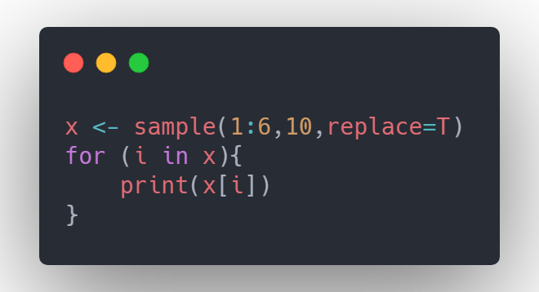

OUTPUT

[1] 2

[1] 4

[1] 6

[1] 3

[1] 3

[1] 4

[1] 6

[1] 3

[1] 3

[1] 3

Question 2

CODE

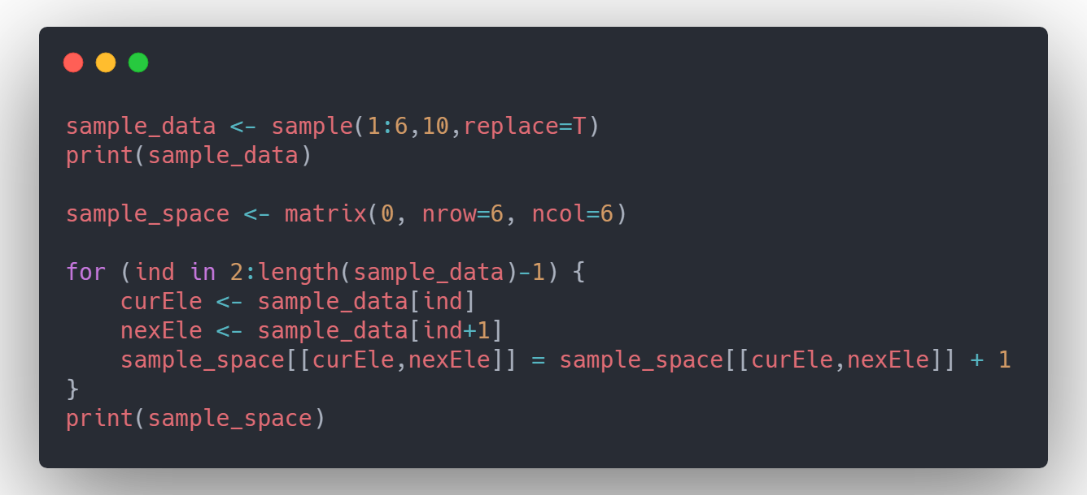

OUTPUT

[1] 5 4 4 4 2 4 5 3 4 4

[,1] [,2] [,3] [,4] [,5] [,6]

[1,] 0 0 0 0 0 0

[2,] 0 0 0 1 0 0

[3,] 0 0 0 1 0 0

[4,] 0 1 0 3 1 0

[5,] 0 0 1 1 0 0

[6,] 0 0 0 0 0 0

Question 3

CODE

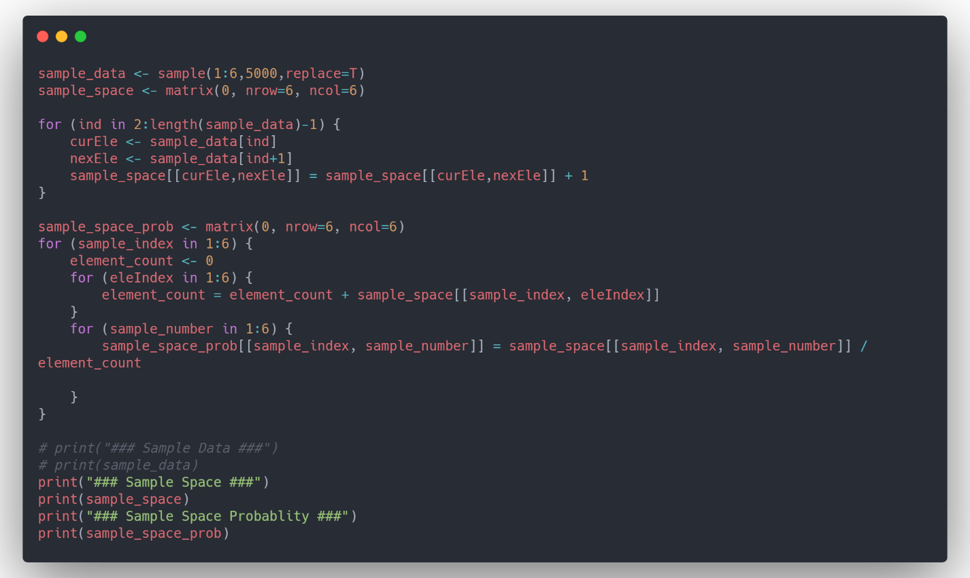

OUTPUT

[1] "### Sample Space ###"

[,1] [,2] [,3] [,4] [,5] [,6]

[1,] 128 127 126 142 135 149

[2,] 138 154 122 145 152 137

[3,] 128 129 146 146 148 132

[4,] 131 138 131 160 155 129

[5,] 133 149 168 120 144 139

[6,] 149 150 136 131 120 132

[1] "### Sample Space Probablity ###"

[,1] [,2] [,3] [,4] [,5] [,6]

[1,] 0.1586121 0.1573730 0.1561338 0.1759603 0.1672862 0.1846344

[2,] 0.1627358 0.1816038 0.1438679 0.1709906 0.1792453 0.1615566

[3,] 0.1544029 0.1556092 0.1761158 0.1761158 0.1785283 0.1592280

[4,] 0.1552133 0.1635071 0.1552133 0.1895735 0.1836493 0.1528436

[5,] 0.1559203 0.1746776 0.1969519 0.1406800 0.1688159 0.1629543

[6,] 0.1821516 0.1833741 0.1662592 0.1601467 0.1466993 0.1613692